5.100: The separated equation of motion has a lower limit of 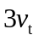 instead of 0; specifically,
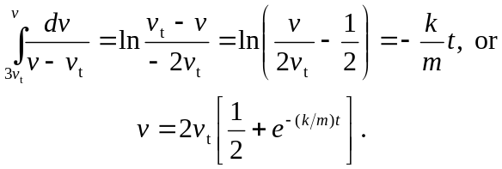
Note that the speed is always greater than .

